Demonstration of Proposed Features
Date | 01 October 2026
Team ID | SWTID-2026-2351
Project Name | Auto Ticket Classification using Flow Designer
Maximum Marks | 1 Mark

Demonstration of Proposed Features
S.No | Feature Name | Description | Status (Implemented / Partial / Pending) | Demonstrated (Yes / No) | Remarks
1 | Incident Workflow form | Ticket form with auto-generated INC number | Implemented | Yes | See new record screenshot
2 | Dependent Subcategory | Subcategory list filtered by Category | Implemented | Yes | Network shows Wi-Fi, Access shows Forgot password, Performance shows Slow computer
3 | Auto classification flow | Flow sets Category / Subcategory when Category is empty | Implemented | Yes | Flow Active and Published
4 | Confirmation email | Email sent after classification | Implemented | Yes | Email preview shown
5 | State tracking | New, In progress, On hold, Resolved, Closed | Implemented | Yes | Choices configured
6 | Update Set export | Configuration exported as XML | Implemented | Yes | Update Set Complete

Feature Implementation Summary
Metric | Value
Total Features Proposed | 6
Total Features Implemented | 6
Total Features Demonstrated | 6
Overall Implementation Rate (%) | 100%
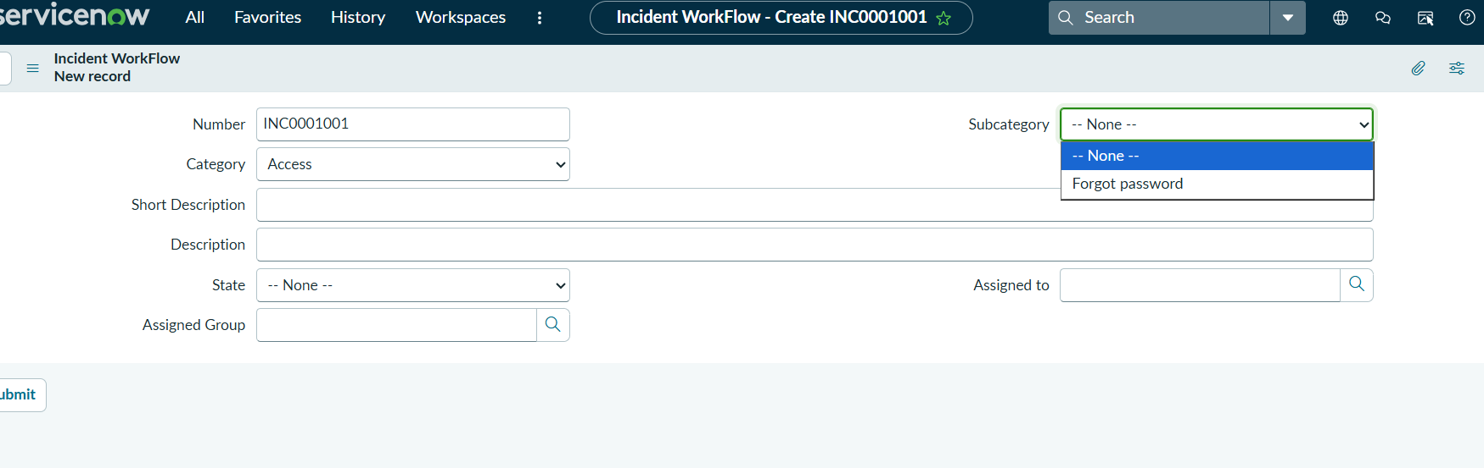
Access shows Forgot password
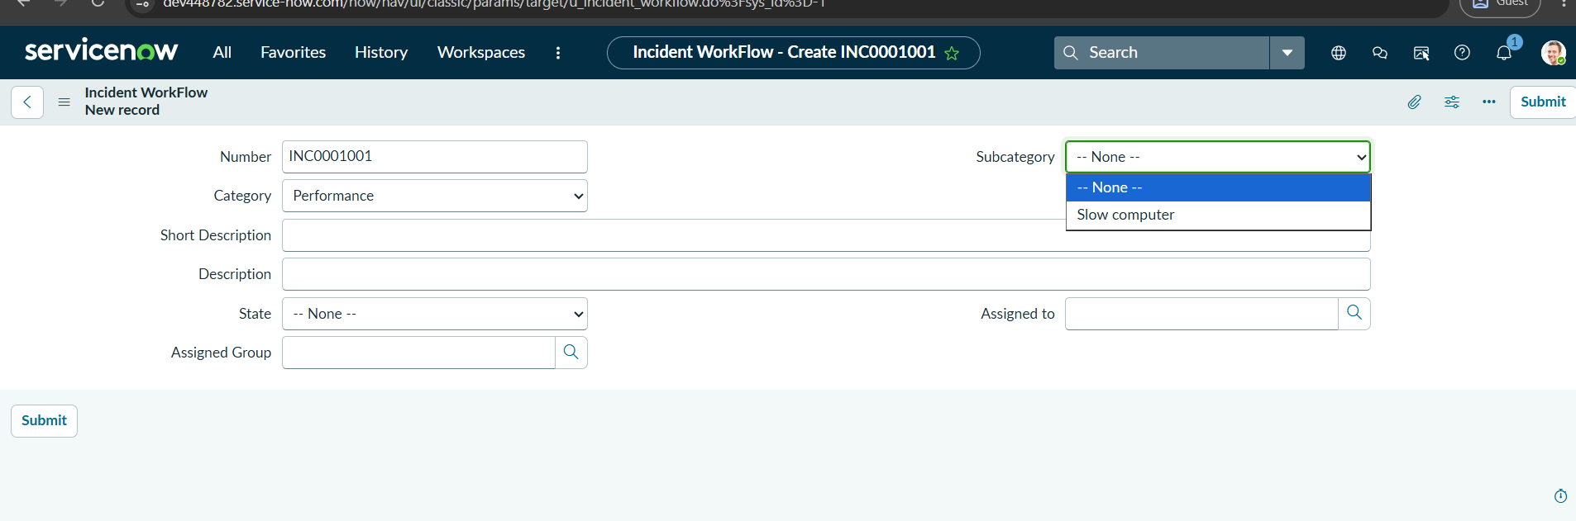
Performance shows Slow computer

